***AIM : TEXT PREPROCESSING IN ORANGE***

***SOLUTION : Open->Orange->File->New***

***1)First we install the Text-Add-ons , Go to Options->Add-ons.***

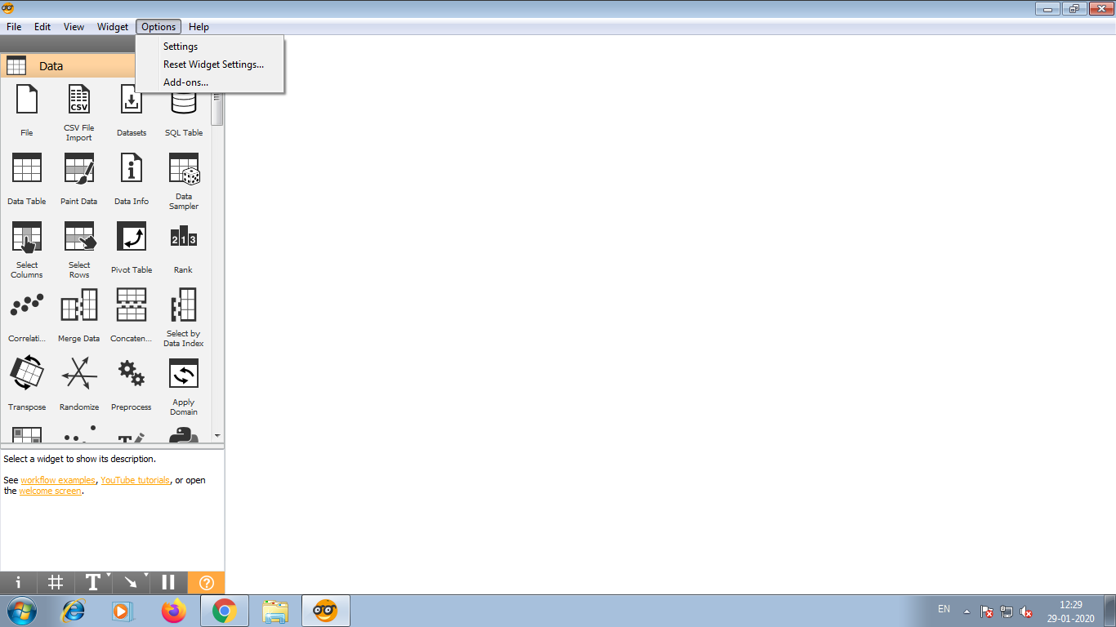

***2)select Text-.***

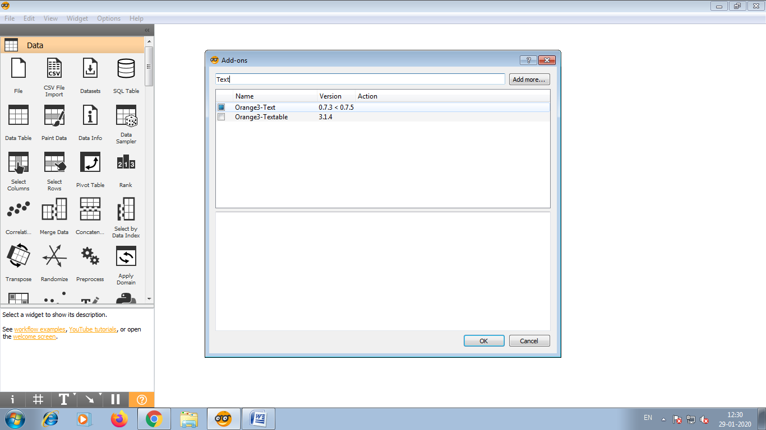

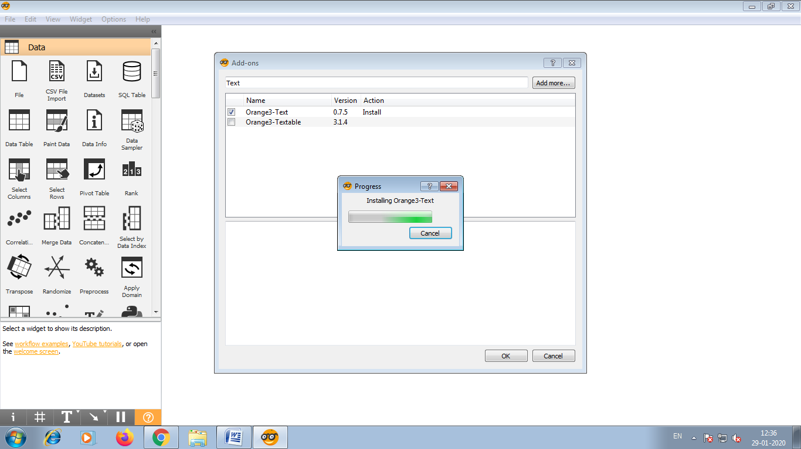

***3)Restart orange to for the add-on to appear***

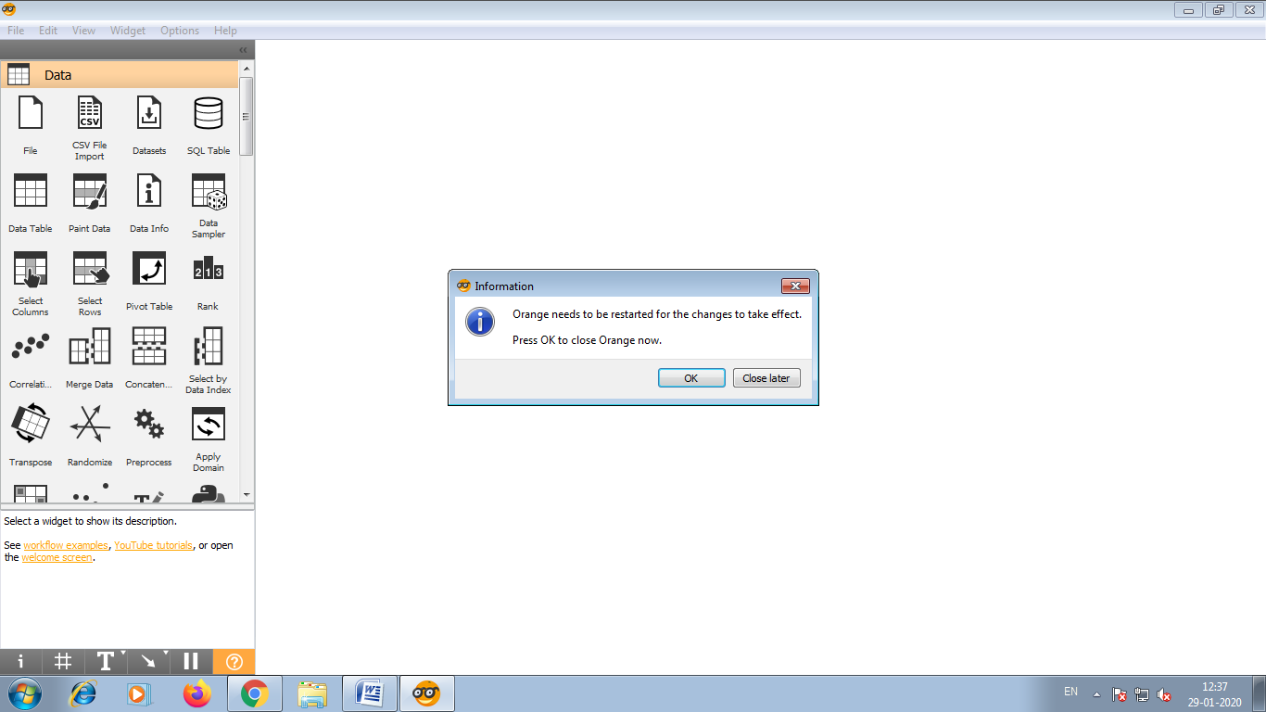

***4)Now let us load the data ->Corpus***

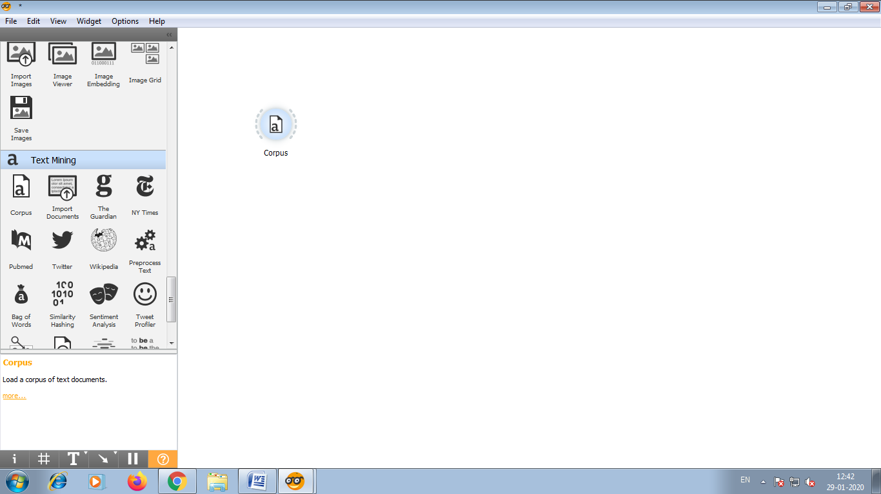

***5)Place Corpus widget on the canvas and open it.Go to browse documentation Corpora ->Select ->and load Grimm-Tales-selected.***

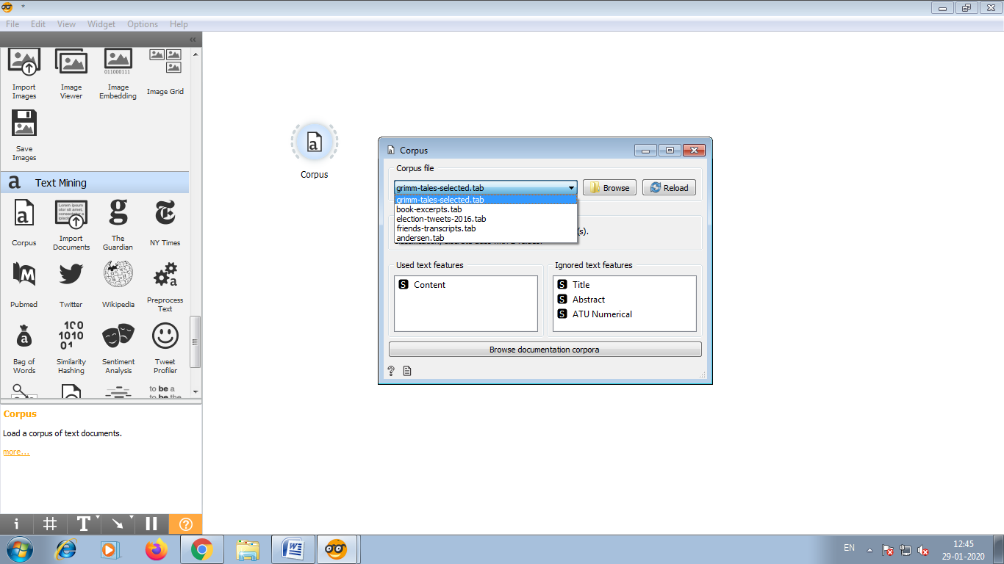

***6)We have 44 Grim tales on the output of the widget.***

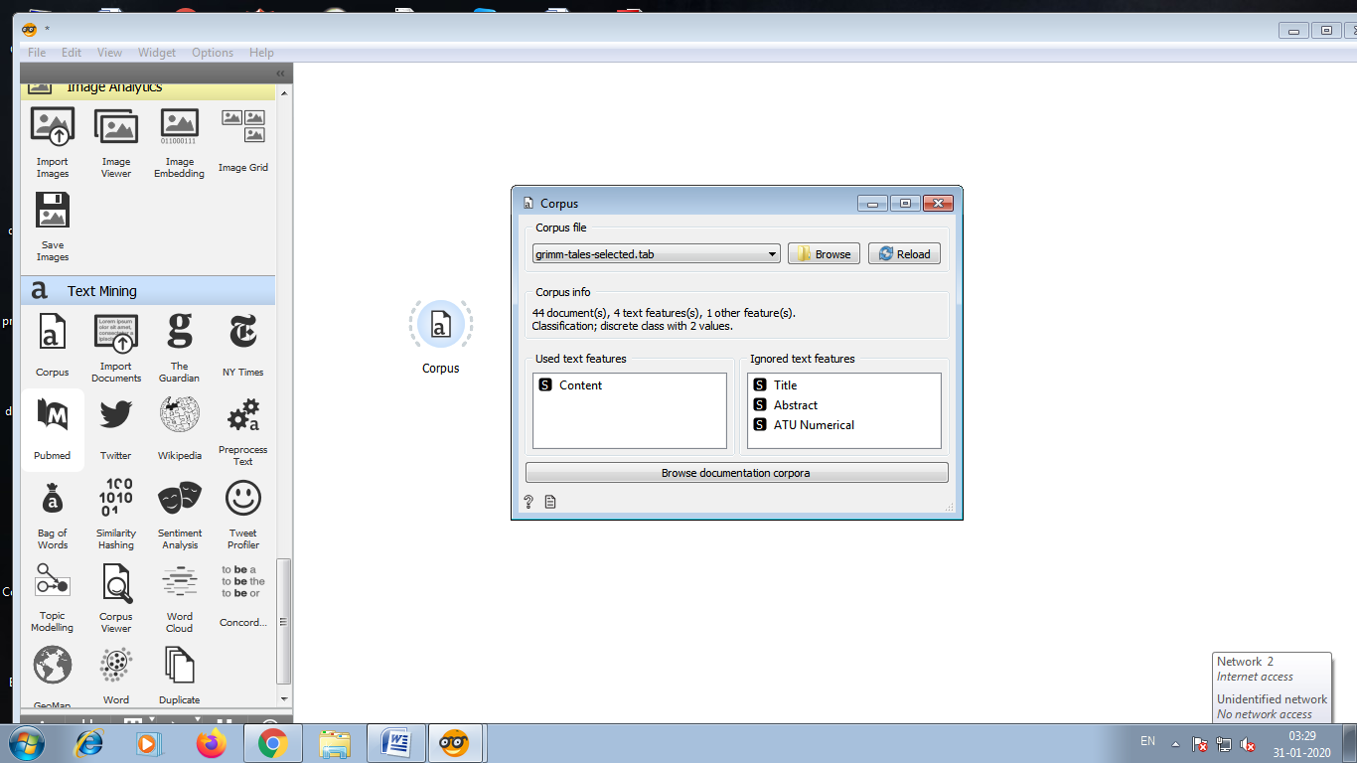

***7)Connect Corpus viewer to corpus.***

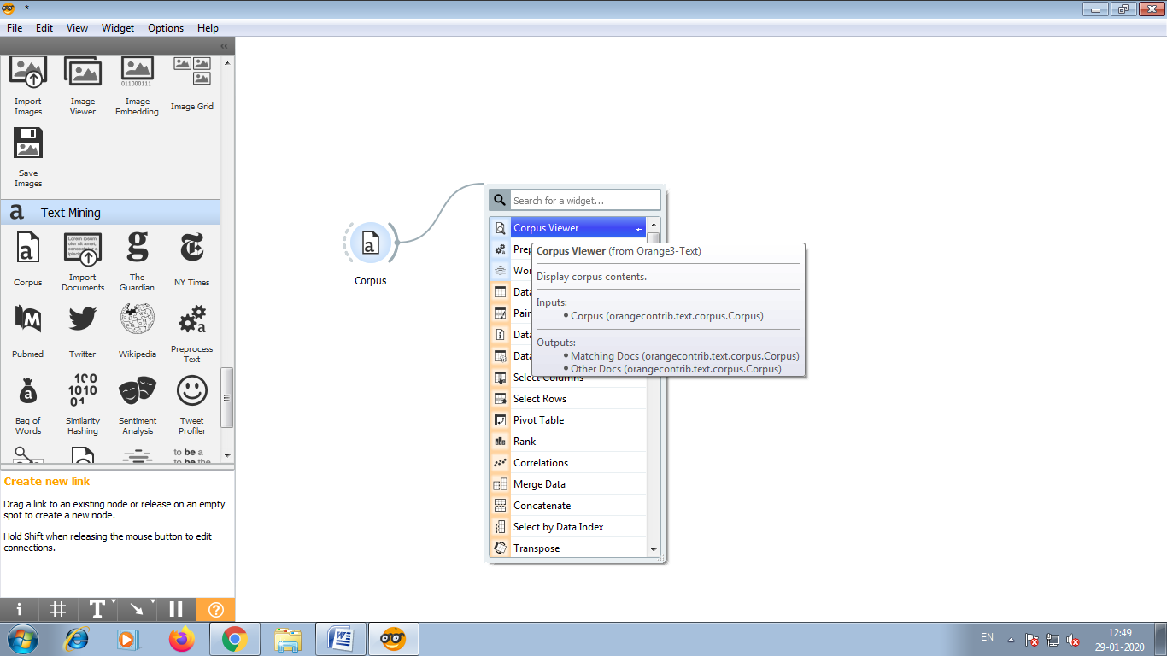

***8)Corpus viewer displays text and enable us to browse it.***

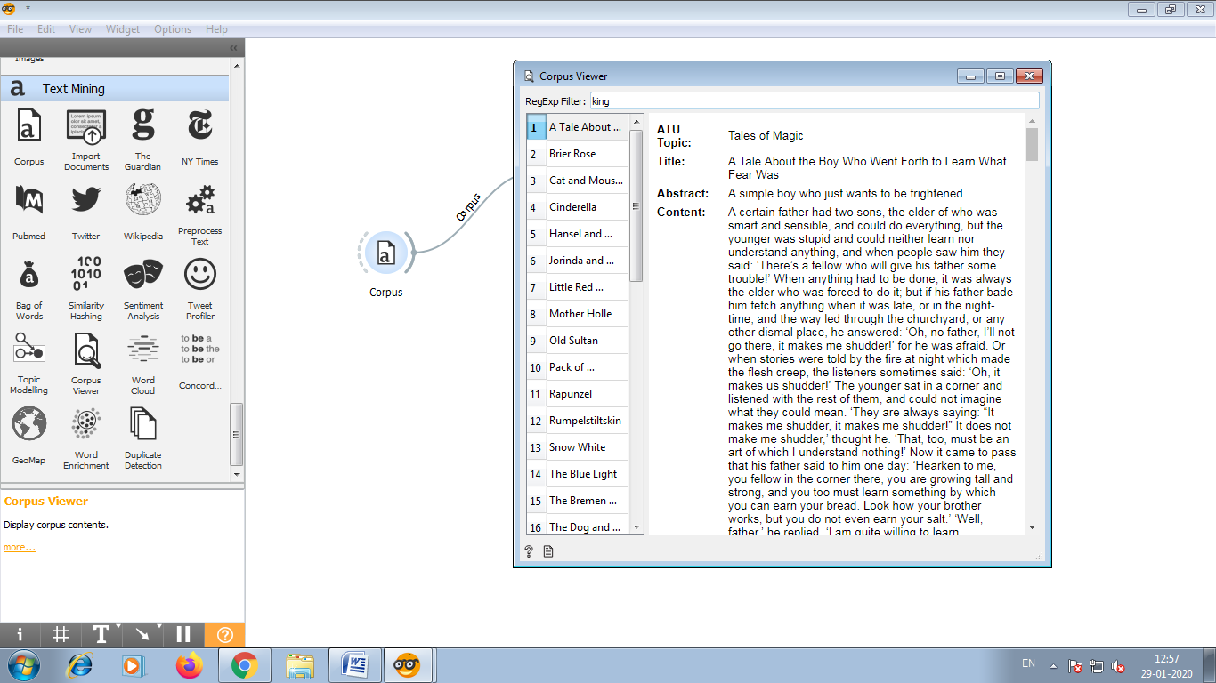

***For example, we can output only those document that contain the word “king”.***

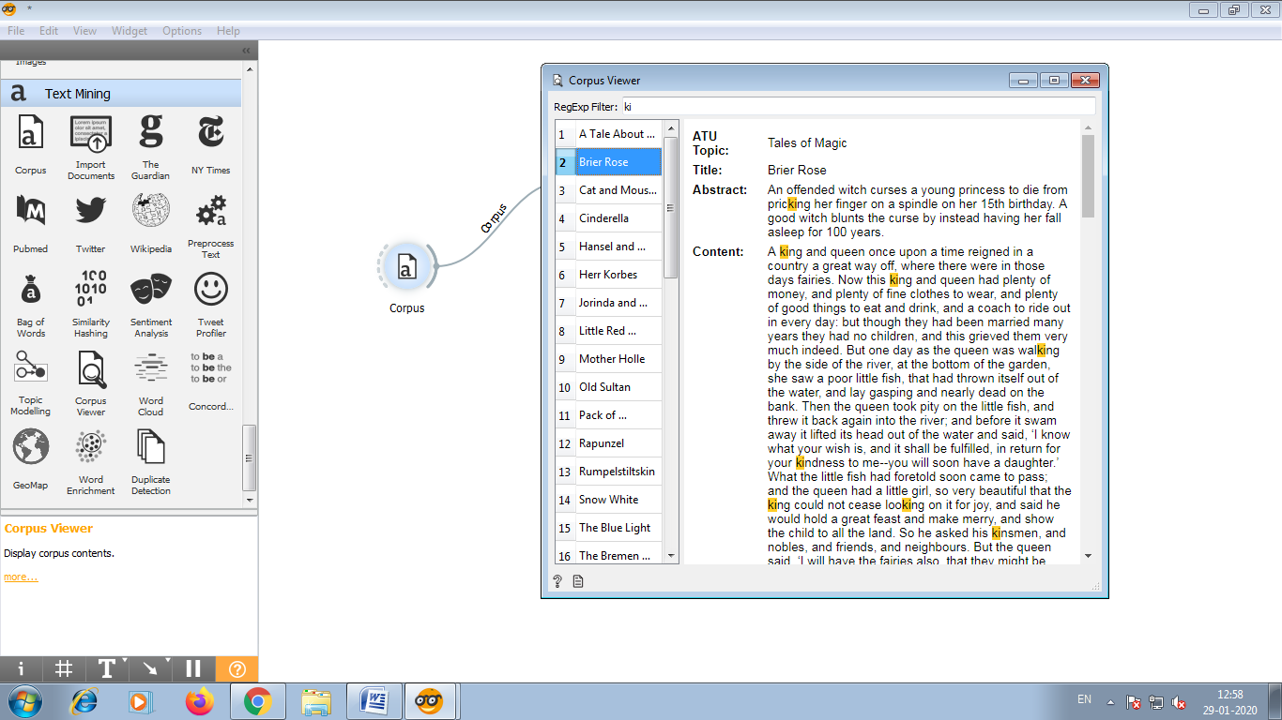

***9)Another widget for visualizing the text is word cloud.***

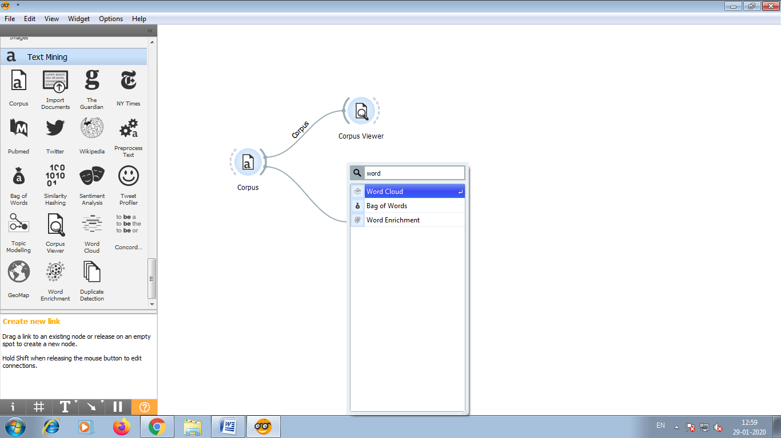

***10)The widget displays word frequencies in a cloud.The more frequently the word appears in the text the larger the word will be. Our word cloud show words such as punctuation and uninformative words.***

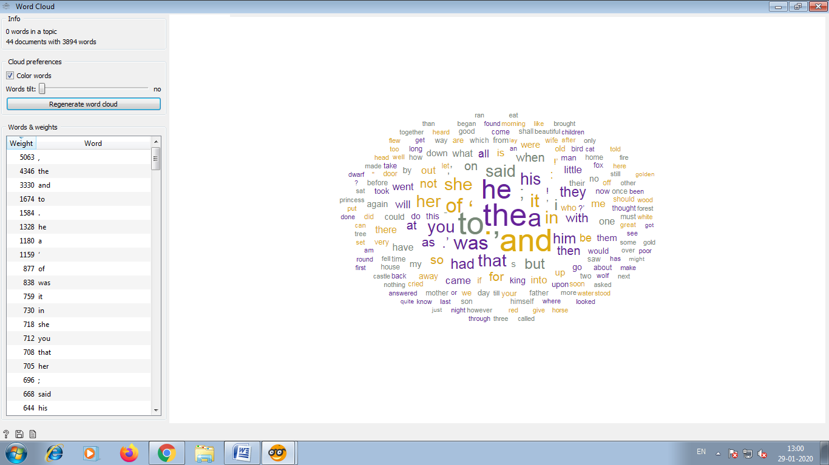

***11)To getting rid of this we will now use preprocess text.***

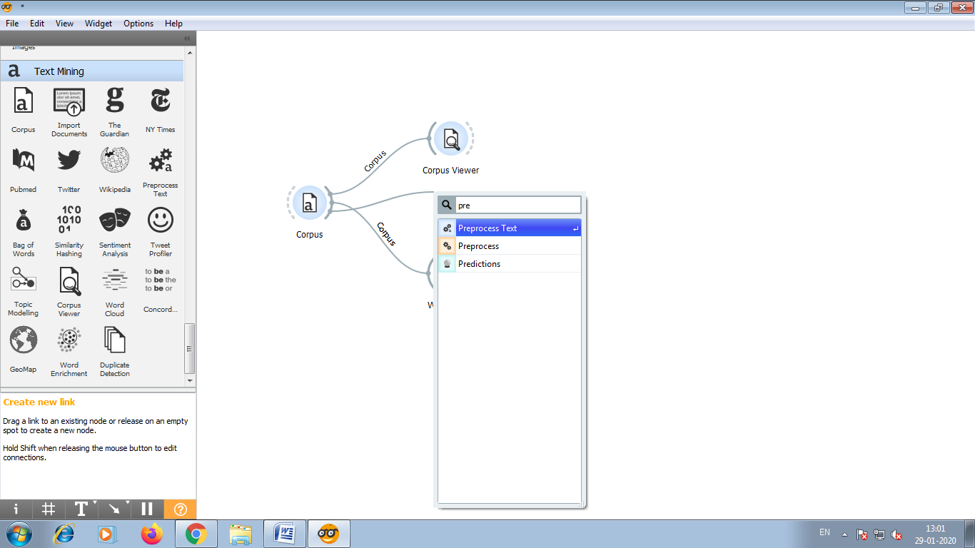

***12)This widget will transform all text to lowercase. Next it will convert text into individuals words and omit the punctuation.***

***Individuals word are called tokens.***

***Finally it will filter out stopwords.***

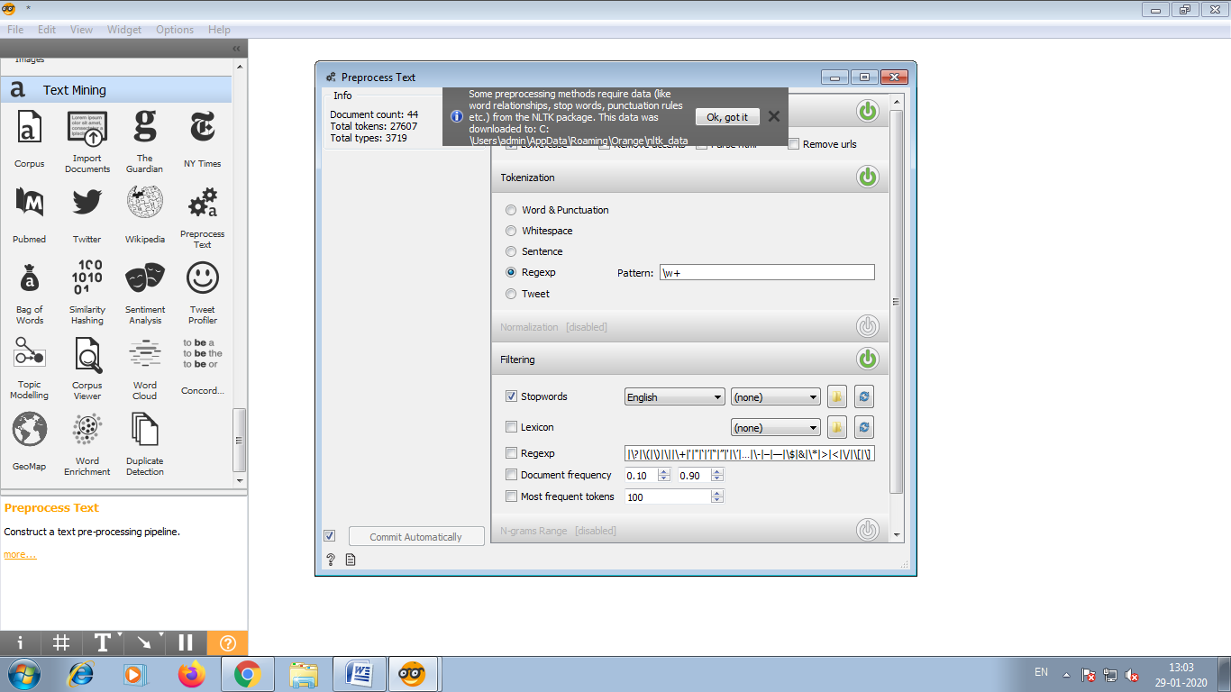

***13)The effects of preprocessing can be visually explored in the word cloud.After preprocessing this visualization looks much better.***

***14)Connect another word cloud with preprocess Text. In this we retained only meaningful words.***

